**Ethan Bard**

**Nhanes Hypertension EDA Results 7-19**

**Health Insurance Analysis**

* **Is there any distinction in whether participants had insurance by race?**
* **Does insurance status have an affect on which kind of drugs participants were prescribed?**
* **Does Insurance status have an affect on whether participants are taking prescriptions?**

| Health Insurance and Prescription Coverage, White w/ hypertension | | | |
| --- | --- | --- | --- |
| Covered By Health Insurance | Insurance Helps Pay for Rx | Freq | perc |
| Yes | Yes | 2115 | 86.26% |
| Yes | No | 135 | 5.51% |
| No | Yes | 3 | 0.12% |
| No | No | 3 | 0.12% |

| Health Insurance and Prescription Coverage, Black w/ hypertension | | | |
| --- | --- | --- | --- |
| Covered By Health Insurance | Insurance Helps Pay for Rx | Freq | perc |
| Yes | Yes | 1428 | 83.36% |
| Yes | No | 68 | 3.97% |
| No | Yes | 10 | 0.58% |
| No | No | 0 | 0% |

For both black and white participants with hypertension, over 80% are covered by insurance and receive financial aid for prescriptions through their insurance.

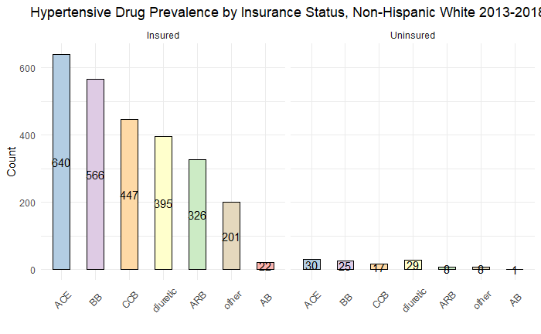

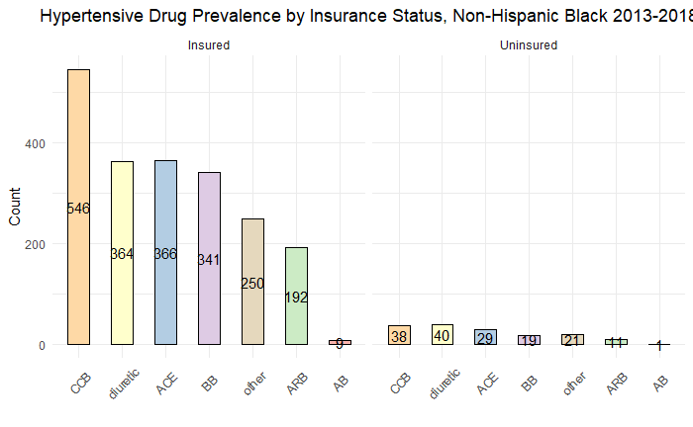

Prevalence of prescribed drug category for hypertension follows similar trend in both insured and uninsured samples.

| Are people with hypertension currently using RX? Insured vs Uninsured, Non-Hispanic White | | | |
| --- | --- | --- | --- |
| Insured? | Taking RX | Freq | perc |
| Yes | Yes | 2081 | 84.87% |
| Yes | No | 175 | 7.14% |
| No | Yes | 121 | 4.93% |
| No | No | 67 | 2.73% |

| Are people with hypertension currently using RX? Insured vs Uninsured, Non-Hispanic Black | | | |
| --- | --- | --- | --- |
| Insured? | Taking RX | Freq | perc |
| Yes | Yes | 1370 | 79.98% |
| Yes | No | 132 | 7.71% |
| No | Yes | 126 | 7.36% |
| No | No | 77 | 4.5% |

Non-Hispanic Black participants with hypertension had a slightly higher proportion of participants who are not insured but still taking prescriptions, as well as participants who were not insured and not taking prescription.

